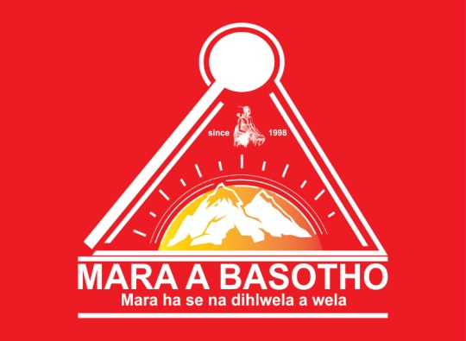

**MARA A BASOTHO**

MEMBERSHIP APPLICATION FORM – 2023 LESOTHO BRANCH

|  |  |
| --- | --- |
| **Name and Surname** |  |
| **ID No** |  |
| **Cellphone No** |  |
| **Street Address** |  |
| **City, Town, Province** |  |
| **Gender & Age** |  |
| **Employed** | Yes/No*(circlewhicheverisapplicable)* |
| **Student** | Yes/No*(circlewhicheverisapplicable)* |
| **Highest Education Level**  (No schooling, Primary School, High School, Degree, Honors, Masters, Doctorate) |  |
| **Sesotho Proficiency**  (Read, write, speak/ fluent, poor, none) |  |
| **Relatives in South Africa** | Yes/No*(circlewhicheverisapplicable)* |
| **Relatives in Lesotho** | Yes/No*(circlewhicheverisapplicable)* |
| **Clan name (Seboko)**  (e.g. Mohlakoana, Motaungwa ha Hlalele, etc) | wa ha |
| **Been a Mara Member Since**  (e.g. 1998) |  |

Bank Details: FNB Gold Business Account: 63000042985

Universal Branch Code: 250655

Account Holder: Mara a Basotho NPC